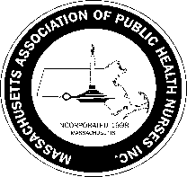
Massachusetts Association of Public Health Nurses

Annual Public Health Nurse Award
Nomination Form for 2023

Criteria for the Annual Public Health Nurse Award:

1. The Nominee must be a current member of MAPHN in good standing for at least two (2) years (A Member in good standing means a fully paid member.).
2. The Nominee must be currently employed as a Public Health Nurse.
3. The Nominee must demonstrate expertise in the specialty practice of public health nursing by:
a. Development of community programs to support population health and well-being
b. Exhibiting leadership qualities to advance public health nursing practice
c. Serving as preceptor/mentor to support other nurses’ learning experiences
d. Involvement in professional organizations to enhance continued personal growth

Nominee’s Name:

Work Address of Nominee:

Nominee’s Email: Nominee’s Phone:

Brief biography/special information regarding Nominee:

Please describe any specific and notable contributions to public health nursing:

-------------------------------------------------------------------------------------------------------------------------------------
Name of individual /MAPHN member nominating the candidate:

E-mail: Phone: Date:

Signature of individual who is nominating the candidate: (e-signature/type your name)

_______________________________________________________________________

Please complete this form and send to Leila Mercer, MAPHN Awards Committee Chair at Admin@MAPHN.org by March 31, 2023.

The Award will be presented at the 2023 MAPHN Annual Conference on May 4th.

2/2023

