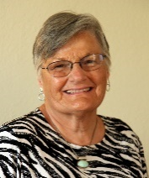 Merrily Evdokimoff RN, PhD
Merrily has over 40 years nursing experience, primarily in community and public health. She has been a direct service provider, manager and chief executive officer. She is currently the owner of
M & J Associates, a consulting firm providing support to home care agencies, non-profits and IT companies involved in software development for both agencies and patients.
She has a BS in Nursing from University of Michigan, a MS in Community Health Nursing from Boston University and a PhD in Nursing from Boston College. Her research interest is in the area of Care transitions and prevention of hospital readmissions of patients.
She is a nationally recognized speaker presenting at the National Association for Home Care, Visiting Nurses Association of America and the American Telehealth Association. In addition to providing consultation services she is an adjunct professor at the University of Massachusetts-Boston teaching Community Health.
Her hobbies include gardening, swimming and spending time with her grandchildren.

