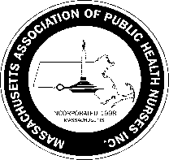

**Massachusetts Association of Public Health Nurses**

**Annual Champion of Public Health Nursing Award**

**Nomination Form for 2022**

Nominee’s Name:

BOH Address of Nominee:

Nominee’s phone       Nominee’s Email

Criteria for the Champion of Public Health Nursing Award:

1. An individual or organization that has supported MAPHN by promoting public health nursing in

Massachusetts.

2. A company who has continually supported MAPHN and public health nursing.

3. A news person/company that has written or spoken about public health nursing & MAPHN and

the positive impact on public health.

4. An author who has written positively on public health nursing & MAPHN in the last year.

Brief Biography/special information regarding candidate:

Please note any specific contributions to supporting MAPHN & Public Health Nursing this candidate has made:

_______________________________________

Name of individual /MAPHN member **nominating** Champion:

Date:       Phone:       E-mail:

Signature of individual who is nominating the Champion__________________________________________

Please complete the form and send to Sherry Petrucci, RN, PHN, MAPHN Awards Committee Chair, Agawam Health Department, 36 Main St. Agawam, MA 01001 The deadline to submit is March 15th, *2022.*

or emailed to [spetrucci@agawam.ma.us](mailto:spetrucci@agawam.ma.us)

If you have any questions, feel free to call Sherry @ 413-726-9722.

The Award will be presented at the 2019 Massachusetts Association of Public Health Nurses Conference.

2/2022