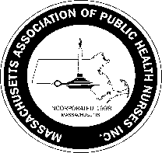
Massachusetts Association of Public Health Nurses

Annual Champion of Public Health Nursing Award
Nomination Form for 2023

Criteria for the Champion of Public Health Nursing Award:

1. An individual or organization that has supported MAPHN by promoting public health nursing in
Massachusetts.
2. A company who has continually supported MAPHN and public health nursing.
3. A news person/company that has written or spoken about public health nursing and MAPHN and
the positive impact on public health.
4. An author who has written positively on public health nursing and MAPHN in the past year.

Nominee’s Name:

Work Address of Nominee:

Nominee’s Email: Nominee’s Phone:

Brief biography/special information regarding the Nominee:

Please describe any specific contributions this Nominee has made in supporting MAPHN and Public Health Nursing:

—--------------------------------------------------------------------------------------------------------------------------------------------
Name of individual /MAPHN member nominating this Candidate:

E-mail: Phone: Date:

Signature of individual who is nominating the Candidate: (electronic/typed name)

_____________________________________________________________________

Please complete the form and send to Leila Mercer, MAPHN Awards Committee Chair, at Admin@MAPHN.org by March 31, 2023.

If you have any questions, feel free to email Leila at Admin@MAPHN.org

The Award will be presented at the 2023 MAPHN Conference on May 4th

2/2023

