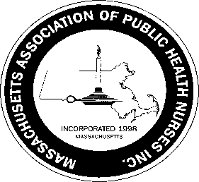**Massachusetts Association of Public Health Nurses**

**Champion of Public Health Nursing Award**

Guidelines

The purpose of this award is to recognize an individual or organization that has been a positive supporter of MAPHN and promoter of public health nursing in the Commonwealth of Massachusetts.

Any member of MAPHN is encouraged to nominate an individual or organization for the Champion of Public Health Nursing Award that would be any Executive board member, President of MAPHN or MAPHN member.

Nomination forms may be obtained at MAPHN.org website. **Nominations must be submitted by March 15, 2022 to the Awards Committee Chair.**

Nominations will be reviewed by the Awards Committee, with final approval from the President of MAPHN. If the awards committee/ or President feels there is no nominee that meets the criteria then an award will not be given that year.

The award will be given annually to one recipient at the MAPHN annual conference.

A nominee for the Champion of Public Health Nursing Award **MUST MEET** the following criteria:

1. An individual or organization that has supported MAPHN by promoting public health

nursing in Massachusetts.

2. A company who has continually supported MAPHN and public health nursing.

3. A news person/company that has written or spoken about public health nursing & MAPHN

and the positive impact on public health.

4. An author who has written positively on public health nursing & MAPHN in the last year.

Return the completed forms to:

Sherry Petrucci, RN, PHN

MAPHN –Awards Committee Chair

Agawam Health Department

36 Main Street

Agawam, MA 01001

Or [Spetrucci@agawam.ma.us](mailto:Spetrucci@agawam.ma.us)

2/2022