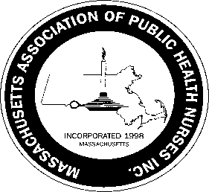
Massachusetts Association of Public Health Nurses

Champion of Public Health Nursing Award 2023
Guidelines
The purpose of this award is to recognize an individual or organization that has been a positive supporter of MAPHN and promoter of public health nursing in the Commonwealth of Massachusetts.
Any member of MAPHN is encouraged to nominate an individual or organization for the Champion of Public Health Nursing Award. Nomination forms may be obtained at MAPHN.org website. Nominations must be submitted by March 31st. 2023 to the Awards Committee Chair, Leila Mercer, at Admin@MAPHN.org .

Nominations will be reviewed by the Awards Committee, with final approval from the President of MAPHN. If the Awards Committee or President feels there is no nominee that meets the criteria then an award will not be given that year.

A Nominee for the Champion of Public Health Nursing Award Must meet the following criteria:
1. An individual or organization that has supported MAPHN by promoting public health
nursing in Massachusetts.

2. A company who has continually supported MAPHN and public health nursing.
3. A news person/company that has written or spoken about public health nursing & MAPHN
and the positive impact on public health.
4. An author who has written positively on public health nursing & MAPHN in the last year.
Return the completed forms to Leila Merer, Awards Committee Chair, at Admin@MAPHN.org by March 31, 2023
The Award will be presented to one recipient at the MAPHN Annual Conference on May 4th.

2/2023

