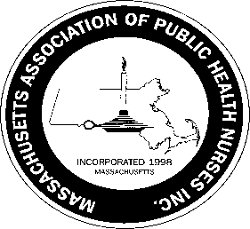**Massachusetts Association of Public Health Nurses**

**MAPHN – Lifetime Achievement Award**

Guidelines

The purpose of this award is to identify and recognize a member of MAPHN who has made significant contributions to MAPHN, the Public Health Nursing Profession, made improvement to the lives of residents in Massachusetts as well as in their own community.

Any member of MAPHN is encouraged to nominate a candidate for recognition for the MAPHN-Lifetime Achievement Award for the current year. Nomination forms can be obtained from the Maphn.org website. **Nomination forms must be returned to the awards committee chair no later than March 15, 2022.** The finalist will be honored at the MAPHN Annual Conference.

A nominee for the MAPHN- Lifetime Achievement Award **MUST MEET** the following criteria:

1. Be a current member and member in good standing of MAPHN for at least five (5) years.

Member in good standing means a fully paid member.

2. Currently hold the position of Public Health Nurse.

3. Exhibit leadership ability.

4. Be active in MAPHN; attendance at local functions, state conferences, and participation in

committee work, etc.

Return the completed forms to:

Sherry Petrucci, RN, PHN

MAPHN –Awards Committee Chair

Agawam Health Department

36 Main Street

Agawam, MA 01001

Or [Spetrucci@agawam.ma.us](mailto:Spetrucci@agawam.ma.us)

2/2022