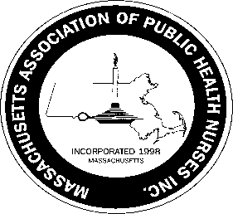
Massachusetts Association of Public Health Nurses

MAPHN Lifetime Achievement Award 2023
Guidelines
The purpose of this award is to identify and recognize a member of MAPHN who has made significant contributions to MAPHN, the Public Health Nursing profession, and has made improvement to the lives of residents in Massachusetts as well as in their own community.
Any member of MAPHN is encouraged to nominate a candidate for recognition for the MAPHN Lifetime Achievement Award. Nomination forms can be obtained from the MAPHN.org website. Nomination forms must be returned to the Awards Committee Chair, Leila Mercer, at Admin@MAPHN.org no later than March 31st, 2023.
A Nominee for the MAPHN Lifetime Achievement Award must meet the following criteria:
1. Be a current member in good standing of MAPHN for at least five (5) years.
(A Member in good standing means a fully paid member.)
2. Currently holds the position of Public Health Nurse
3. Exhibit leadership ability
4. Be active in MAPHN organization, e.g., Committee(s) member, Board member, attendance/participation at MAPHN-supported functions and conferences

Return the completed forms to: Leila Mercer , Awards Committee Chair, at Admin@MAPHN.org
The Award will be presented to the recipient at the MAPHN Annual Conference on May 4th.

2/2023

