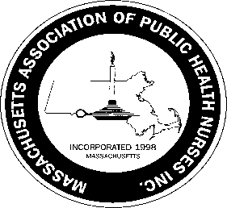
Massachusetts Association of Public Health Nurses
Annual Public Health Nurse Award 2023
Guidelines
The purpose of this award is to recognize a current member of MAPHN that has shown leadership qualities, and has demonstrated expertise in the field of public health nursing.
Any member of MAPHN is encouraged to nominate a member for the Annual Public Health Nurse Award. Nomination forms may be obtained at MAPHN.org website. Nominations must be submitted by March 31st, 2023 to the Awards Committee Chair, Leila Mercer , at Admin@MAPHN.org

Nominations will be reviewed by the Awards Committee, with final approval from the President of MAPHN. If the Awards Committee or President feels there is no nominee that meets the criteria then an award will not be given that year.

The award will be presented to the recipient at the MAPHN annual conference.

The nominee for the Annual Public Health Nurse Award must meet the following criteria:
1. Current member in good standing with MAPHN for at least two (2) years
2. Currently employed as a Public Health Nurse
3. Must demonstrate expertise in the specialty of public health nursing by:
a. development of innovative community programs impacting public health nursing
b. exhibiting leadership qualities
c. being a preceptor/mentor
d. being involved in professional organizations
Submit nomination forms to: Leila Mercer, Awards Committee Chair, at Admin@MAPHN.org
2/2023

