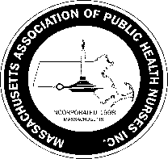
Massachusetts Association of Public Health Nurses

MAPHN Lifetime Achievement Award
Nomination Form for 2023

Criteria for the Lifetime Achievement Award:
1. Nominee must be a current member of MAPHN in good standing for at least five (5) years.
(A Member in good standing means a fully paid member.)
2. Nominee must currently hold the position of Public Health Nurse.
3. Nominee exhibits leadership ability.
4. Nominee must be active in the MAPHN organization: e.g., Committee(s) member, Board member, attendance/participation at MAPHN-supported functions and conferences

Nominee’s Name:

Work Address of Nominee:

Nominee’s Email: Nominee’s Phone:

Brief Biography/special information regarding candidate:

Please describe any specific contributions this Nominee has made to supporting MAPHN and Public Health Nursing:

—--------------------------------------------------------------------------------------------------------------------------------
Name of individual /MAPHN member nominating this Candidate:

E-mail: e: :

Signature of individual who is nominating the Candidate:

__________________________________________________________________________

Please complete the form and send to Leila Mercer , Awards Commitee Chair, at Admin@MAPHN.org by March 31st, 2023

The Award will be presented at the 2023 MAPHN Annual Conference on May 4th.

1/2023

